UCAR/CVI Laser Hygrometer

Operations Guide

MayComm Instruments, LLC

981 W. Arrow Highway, #377
San Dimas, CA 91773

Rev. A, December 2005
Table of Contents

Introduction 3

Cable and Gas Flow Connections 3

Operational Ranges 3

Installation Considerations 5

Software Operation 4

LED Front Panel Indicator 4

Contact Information 5

Appendix A – Connector Pinouts 6

Appendix B – Calibration Data 7

Appendix C - Humidity Conversion Equations 8

Introduction
The UCAR/CVI laser hygrometer is designed to provide measurements of water vapor mixing ratio (converted to absolute humidity for output) within a heated sample cell resident to the custom enclosure provided. The optical absorption path length is approximately 2.54 cm. A fiber-coupled distributed feedback diode laser laser continuously scans the H₂O spectral line at 7299.4 cm⁻¹ (1370 nm) to provide a second harmonic (2f) spectrum to the control electronics. Four individual spectra are averaged (in approximately one second), then analyzed by the microcontroller software to produce the H₂O concentration as absolute humidity in units of g/m³ at the pressure and temperature of the sample cell. Pressure and temperature inside the sample cell, required for real-time data processing, are measured using sensors resident to the sample cell. The sample cell is thermostatted at approximately +45 C to avoid condensation of water at the relatively high H₂O concentrations that may be encountered.

The instrument is a custom designed research instrument and is not a commercial product produced in quantity. Therefore, this Operations Guide is only a brief introduction to the operational procedures and a description of the initial setup of the system as delivered. After power up the system performs a 15 s initialization and begins output at 9600 baud on the RS232C serial port. No setup or other inputs are required other than the physical cable connections needed to supply power (+28 VDC and +5VDC) and to receive the serial output data, and a suitable warmup time for the sample cell temperature to stabilize (approximately 10 minutes from a cold power up).

Cable and Gas Flow Connections
+28 VDC and +5 VDC are supplied via a 4-pin twist-lock BendixTM connector located on the front panel of the enclosure. Serial output is provided via a standard 9-pin "D" connector adjacent to the power connector. Pinouts for these connectors are given in Appendix A. Gas inlet and outlet connections are via 1/4" swagelock fittings on the back panel. Flow direction is irrelevant to the measurement so the inlet / outlet designations can be chosen based on convenience.

Operational Ranges
The system has been set up for operation over the range 100-1050 mbar in pressure, and 0 - 50 C in temperature (for the enclosure), with the sample cell thermostatted at approximately +45 C. Spectral line parameters for H₂O were taken from the 2004 HITRAN database, which are far superior to data on earlier versions of this database (especially the 2000 version). Calibration against a chilled mirror hygrometer (Edgetech Dewprime 2001) was carried out using a flow dilution system which allowed measurements over a dew point range of -55 C (below the detection limit for this system) to +17.6 C, and over the full range of pressures expected to be encounted by the system.

Nonlinearities in Beer's law at high absorption levels, and increased effects of self-broadening by H₂O at high H₂O levels, have been accounted for in the present version of the software via laboratory calibrations at varying pressures and H₂O concentrations up to +17.6 C dew points (roughly 53,000 ppmv at 400 mbar and 21000 ppmv at 1000 mbar ...17.6 C dew point is the upper limit of the laboratory generation system which does not contain heated sample lines). Beer's law is linear to the 1% error level up to line center absorption levels of approximately 13.5% (ie. the point where e^{-x} / (1-x) = 1.01, with x = absorption = 1 - transmission; at x = 0.135 this ratio is ~ 1.01). For a 2.54 cm optical path and +45 C, this level of absorption is reached at ~8.9 g/m³ of H₂O at 100 mbar, and 60.5 g/m³ of H₂O at 1000 mbar.

H₂O self broadening effects also influence linearity at higher H₂O levels, independent of Beer's law nonlinearities, and the software makes a correction for this as well based on HITRAN 2004 air and self broadening coefficients. Although laboratory calibrations above 17.6 C dew points were not possible, the electronic gains are configured to accomodate H₂O values as high as 40 g/m3 at any pressure in the 100 - 1050 mbar range. Software extrapolation to these higher levels is subject to any errors in the HITRAN 2004 line parameter values, and additional calibration data points may be needed if these parameters prove to be insufficient for the accuracy or measurement ranges required.

Software Operation
At power-up the system executes a control program resident in the microcontroller which scans the laser, digitizes the spectrum, processes for the H₂O volume mixing ratio, converts to absolute humidity (g/m³) and outputs the serial data stream. The measured H₂O values and housekeeping diagnostics are output on the serial port (9600 baud, 8 bits, 1 stop bit, no parity). A null modem RS232 cable is required to receive the output data stream on a remote computer. Each serial output data line is formatted as in the following example (C format string is: "%7.2f %7.2f %6.2f \r\n"):

11.06 514.21 47.17 <CR><LF>

where the order of parameters (left to right, CR=carriage return, LF = linefeed) is:

1. H₂O concentration in g/m³ at the measured P and T of the sample cell
2. Sample cell total pressure in mbar
3. Sample cell temperature in C

Contact information
If there are any problems with the hygrometer contact Randy May at MayComm Instruments, LLC between 8:30 am and 5:30 pm Pacific Time, Monday through Saturday:

Email: rmay@maycomm.com
Telephone: 818-653-7153 (Cell)

Mailing Address: 981 W. Arrow Highway, #377
San Dimas, CA 91773
Appendix A - Connector Pinouts

Power Connector (PT02E-8-4P, 4-pin male Bendix type )

Pin Signal
A +28V Return (Ground)
B +28 VDC (+ 3V)
C +5 VDC (-0.10V, +0.20V)
D +5V Return (Ground)

_______________________________________

Serial Port (9-pin D-sub male, 3-wire)

Pin Signal
1 N/C
2 RXD
3 TXD
4 N/C
5 Ground
6 N/C
7 N/C
8 N/C
9 N/C

(A standard null modem cable is needed for connection to a monitor device)

Appendix B - Calibration Data

Top plot shows ~constant dew point generation data (chilled mirror vs. TDL as function of pressure) at lower H₂O values in the linear range. Bottom plot shows higher H₂O data and fit in the 400 - 1000 mb range. Dew point upper limit was 17.6 C (sample lines not heated).
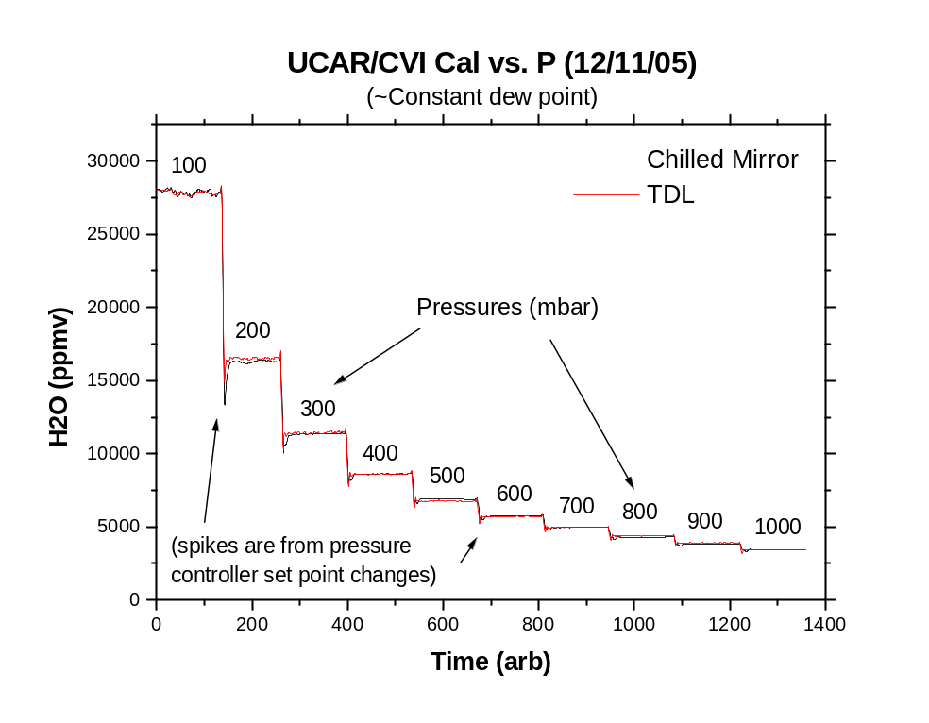
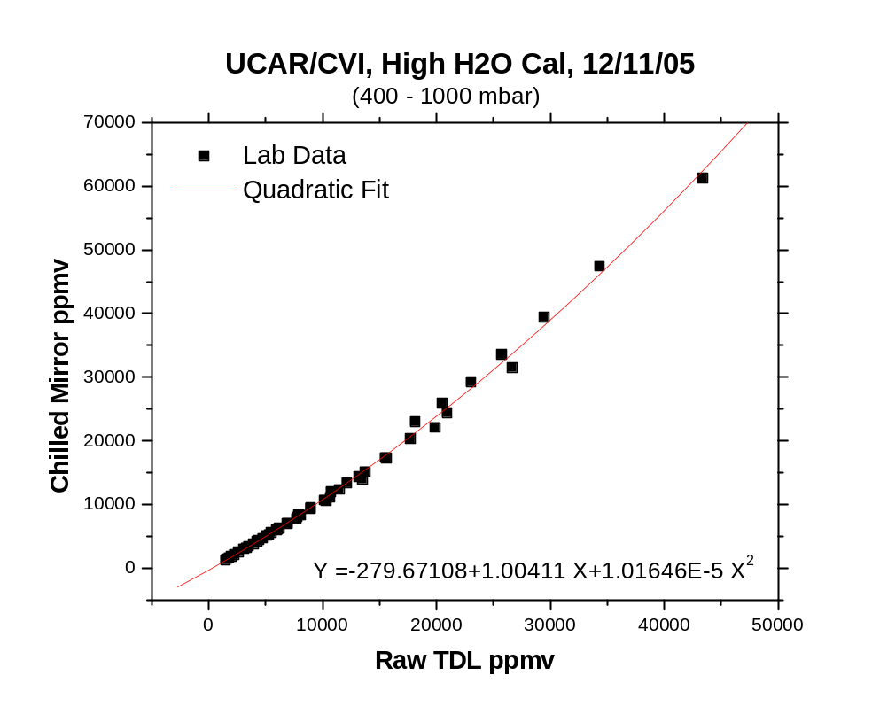

Appendix C - Humidity Conversion Equations
(from A. Buck, Buck Research Instruments)

HUMIDITY CONVERSION EQUATIONS

Arden L. Buck
Buck Research, 5375 Western Ave., Boulder, CO 80301
Phone: 303-442-6055
(Revised 5/96)

Computer-efficient algorithms for converting among several humidity units, as used in HCONL, are given here.

DP = dew or frost point in deg C
e = vapor pressure in millibars
es = saturation vapor pressure in millibars
P = pressure in millibars
r = mixing ratio by weight in ppm
RH = relative humidity in percent
rho = absolute humidity in g/m3
rhos = absolute humidity at saturation
T = temperature in deg C
Tk = absolute temperature in K

Saturation vapor pressure (es) = f1(T) = e/RH

Dew/frost point (DP) = f2(e) (e)
= f2[r x P/(622 x 103 + r] (r)
= f2(RH x f1(T)/100) (RH)
= f2(rho x Tk/216.7) (rho)

Vapor pressure (e) = f1(DP) (DP)
= r x P/(622 x 103 + r) (r)
= RH x f1(T)/100 (RH)
= rho x Tk/216.7 (rho)

Mixing ratio (r), ppmw = 622x103 x e/(P-e) (e)
= 622x103 x f1(DP)/[P - f1(DP)] (DP)
= 622x103 x RH x es/(100 x P - RH x es) (RH)
= 622x103 x rho x Tk/(216.7 x P - rho x Tk) (rho)

Relative humidity (RH) = 100 x f1(DP)/f1(T) (DP)
= 100 x e/es (e)
= 100 x r x P/[(622x103 + r) x es] (r)
= 100 x rho x Tk/(216.7 x es) (rho)

Absolute humidity (rho) = 216.7 x f1(DP)/Tk (DP)
= 216.7 x e/Tk (e)
= 0.2167 x r x P/[(622 + .001 x r) x Tk] (r)
= 216.7 x RH x es/(100 x Tk) (RH)

mixing ratio by volume = mixing ratio by weight x 1.6077

grains/lb = r x 0.007

Precipitable cm per km = rho / 10

NOTE 1: f1(DP) and f2(e) are variations on vapor pressure formulations found in Buck, A: J Appl Met 20, pp 1527-1532 (1981). They are given by:

e vs. DP or es vs. T:

f1(DP) = EF x aw x exp [(bw - DP/dw) x DP/(DP + cw)] (over water)

= EF x ai x exp [(bi - DP/di) x DP/(DP + ci)] (over ice)

DP vs. e or T vs. es:

f2(e) = dw/2 x [bw - s - ((bw - s)2 - 4 cw x s/dw)1/2] (over water)
= di/2 x [bi - s - ((bi - s)2 - 4 ci x s/di)1/2] (over ice)

where:
aw = 6.1121 ai = 6.1115
bw = 18.678 bi = 23.036
cw = 257.14 ci = 279.82
dw = 234.5 di = 333.7

s = ln (e/EF) - ln (aw or ai)
EF = 1 + 10-4 [2.2 + P (0.0383 + 6.4 x 10-5 T2)],
where P is in kPa and T is in oC.

NOTE 2: RH is defined here using es with respect to ice below freezing. However, RH is also frequently defined using es with respect to water, even below freezing.

NOTE 3: These conversions are intended for use with moist air rather than pure water vapor. They therefore include EF, the enhancement factor, which corrects for the slight departure of the behavior of water in air from that of a pure gas.

NOTE 4 (5/92): The definitions f1 and f2 for ice agree with an extrapolation of NBS values down to -120 deg C, within 0.5%.

